**Empathy Map Canvas**

|  |  |  |  |  |  |  |
| --- | --- | --- | --- | --- | --- | --- |
| *Designed for:* |  | *Designed by:* |  | *Date:* |  | *Version:* |
|  |  |  |  |  |  |  |

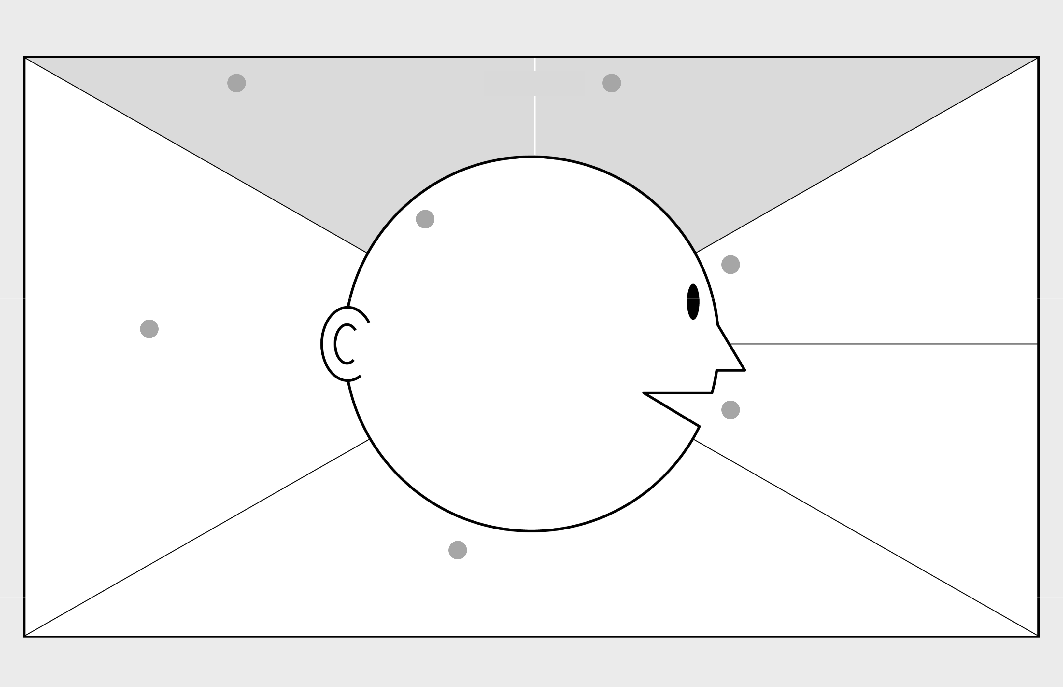

|  |  |  |
| --- | --- | --- |
| 1 WHO are we empathizing with? | **GOAL** | 2 What do they need to DO? |

Who is the person we want to understand?

What is the situation they are in?

What is their role in the situation?

- We want to understand customers who will get improved assistance from the relationship managers for their in-house call management centre.

- They are in a situation where call flow rates are randomized to get their suitable RMs.

- Their role in this situation is to become customers who will use travel services with inbound and outbound calls method.

What do they need to do differently?

What job(s) do they want or need to get done?

What decision(s) do they need to make?

How will we know they were successful?

- Customer see that the call management service is good but it would be great if the call flow rate is matched with the right RMs.

- They see that the holiday packages offered by a major travel company using inbound and outbound calls.

- They see other customer can get holiday packages information from call routing provide by a travel company

- Customer are trying to read for information about travel services.

- Travel companies must improve the call flow rate to match customers based on RM performance and product knowledge.

- They offer improved call routing and dynamic call flow control for both inbound and outbound calls.

- They need to create customer profiles to be used as skill matcher between end-customer and RMs based on their profiles.

- If the customer makes repeat orders or customers from particular postcodes will affect the scores which will determine who will be served first.

1. What do they THINK and FEEL?
2. What do they HEAR?

What are they hearing others say?

What are they hearing from friends?

What are they hearing from colleagues?

What are they hearing second-hand?

|  |  |
| --- | --- |
| PAINS | GAINS |
| What are their fears, | What are their wants, |
| frustrations, and anxieties? | needs, hopes and dreams? |
|  |  |

What other thoughts and feelings might motivate their behavior?

1. What do they DO?

What do they do today?

What behavior have we observed?

What can we imagine them doing?

1. What do they SEE?

What do they see in the marketplace?

What do they see in their immediate environment?

What do they see others saying and doing?

What are they watching and reading?

1. What do they SAY?

What have we heard them say?

What can we imagine them saying?

- They said they want reliable assistance from travel companies to get holiday packages deals.

- They have concern about user privacy because the profiler tool requires customers to fill in their personal information.

Last updated on 16 July 2017. Download a copy of this canvas at http://gamestorming.com/empathy-map/ © 2017 Dave Gray, xplane.com